# CS 255 System Design Document Template

## UML Diagrams

### UML Use Case Diagram

### UML Activity Diagrams

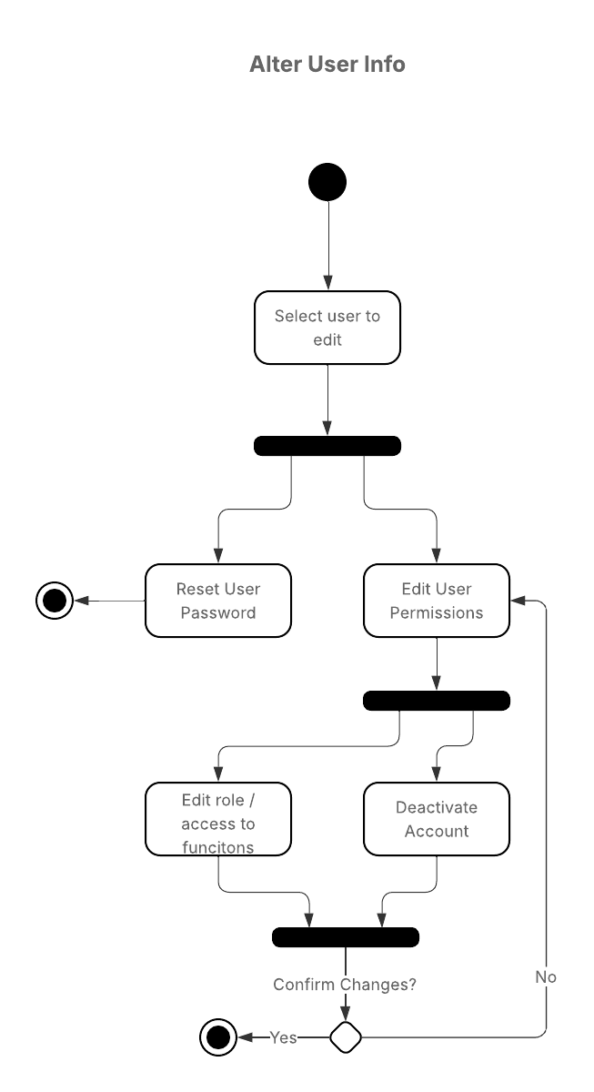

### UML Sequence Diagram

### UML Class Diagram

## Technical Requirements

Hardware

* Internet access
* Device capable of running web browsers

Software

* Cloud-based server and storage
* Database management application